Section 2.1: 8, 10, 14, 18, 20, 32

8)

a). {x ∈ R|x is an integer greater than 1}

**No.**

b). {x ∈ R|x is the square of an integer}

**No.**

c). {2, {2}}

**Yes.**

d). {{2}, {{2}}}

**Yes**.

e). {{2}, {2, {2}}}

**Yes.**

f). {{{{2}}}}

**No.**

10)

a). ø ∈ { ø }

**True.**

b). ø ∈ { ø, { ø }}

**True.**

c). { ø } ∈ { ø }

**False.**

d). { ø } ∈ {{ ø }}

**True.**

e). { ø } ⊂ { ø, { ø }}

**True.**

f). {{ ø }} ⊂ { ø, { ø }}

**True.**

sets are not equal.)

g). {{ ø }} ⊂ {{ ø }, { ø }}

**False. These are equal.**

14)

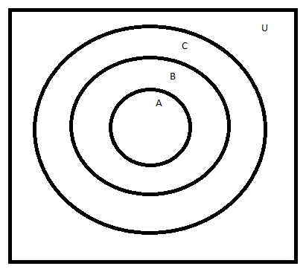

18) Find two sets A and B such that A ∈ B and A ⊆ B.

**A = {1}**

**B = {2, {1}}**

20)

a). | ø |

**0 this is not a set**

b) |{ ø }|

**1**

c) . |{ ø, { ø }}|

**2**

d) |{ ø, { ø }, { ø, { ø }}}|

**3**

32) Let A = {a, b, c}, B = {x, y}. and C = {0, 1}

a) A x B x C

**{(a, x, 0), (a, x, 1), (a, y, 0), (a, y, 1), (b, x, 0), (b, x, 1), (b, y, 0), (b, y, 1),**

**(c, x, 0), (c, x, 1), (c, y, 0), (c, y, 1)}**

b) C x B x A

**{(0, x, a), (0, x, b), (0, x, c), (1, x, a), (1, x, b), (1, x, c), (0, y, a), (0, y, b),**

**(0, y, c), (1, y, a), (1, y, b), (1, y, c)}**

c) C x A x B

**{(0, a, x), (0, a, y), (0, b, x), (0, b, y), (0, c, x), (0, c, y), (1, a, x), (1, a, y),**

**(1, b, x), (1, b, y), (1, c, x), (1, c, y)}**d) B x B x B

**{(x, x, x),(x, x, y),(x, y, x),(x, y, y),(y, x, x),(y, x, y),(y, y, x),(y, y, y)}**